**Telehealth Management Platform**

Deployment, Installation, Back-Out, and Rollback Guide



Oct 2023

Department of Veterans Affairs

Office of Information and Technology (OI&T)

**Revision History**

| Date | Version | Description | Author |
| --- | --- | --- | --- |
| October 24, 2023 | 9.0 | Instructions for Release 5.1.1 | Emily Schroen/TMP Developer |
| January 20, 2023 | 8.0 | Instructions for Release 5.0.0.0 | Peter Cisewski/Microsoft Developer |
| April 29, 2022 | 7.1 | Renamed release 4.9.0.10 to <FUTURE RELEASE> | Murthy Puvvada/ TMP Developer |
| Jan 11, 2021 | 7.0 | Added URL to CRM code and deployment instructions for VVS version upgrade | Shannon Utting/TMP PMO Team |
| September 25, 2020 | 6.0 | Added URL to CRM code and deployment instructions for combined releases TMP 4.8.1 and 4.8.2. | Shannon Utting/TMP PMO Team |
| August 4, 2020 | 5.0 | Updated Deployment Date for TMP VistA Patch SD*5.3*754. | Shannon Utting/TMP PMO Team |
| June 19, 2020 | 4.0 | Added URL to CRM code and deployment instructions for TMP 4.8.0. | Shannon Utting/TMP PMO Team |
| June 18, 2020 | 3.0 | Added URL to CRM code and deployment instructions for TMP 4.6.10 (Hotfix 10) | Shannon Utting/TMP PMO Team |
| June 17, 2020 | 2.9 | Updated Deployment Date for TMP VistA Patch SD*5.3*746v1. | Shannon Utting/TMP PMO Team |
| May 27, 2020 | 2.8 | Added Deployment instructions for TMP VistA Patch SD*5.3*746v1. | Shannon Utting/TMP PMO Team |
| May 27, 2020 | 2.7 | Added URL to CRM code and deployment instructions for TMP 4.6.9 (Hotfix 9) | Shannon Utting/TMP PMO Team |
| May 13, 2020 | 2.6 | TMP D365 Product Upgrade Wave 1 | Shannon Utting/TMP PMO Team |
| May 6, 2020 | 2.5 | Added URL to CRM code and deployment instructions for TMP 4.6 Hotfix 8. | Shannon Utting/TMP PMO Team |
| April 3, 2020 | 2.4 | Added URL to CRM code and deployment instructions for TMP 4.6 Hotfix 7. | Shannon Utting/TMP PMO Team |
| March 26, 2020 | 2.3 | Added Deployment instructions for TMP VistA Patch SD*5.3*714v4. | Shannon Utting/TMP PMO Team |
| January 21, 2020 | 2.2 | Added URL to CRM code and deployment instructions for TMP 4.6 Hotfix 6. | Shannon Utting/TMP PMO Team |
| November 25, 2019 | 2.1 | Added URL to CRM code and deployment instructions for TMP 4.6 Hotfix 5. | Shannon Utting/TMP PMO Team |
| November 19, 2019 | 2.0 | Added URL to CRM code and deployment instructions for TMP 4.6 Hotfix 4. | Shannon Utting/TMP PMO Team |
| November 6, 2019 | 1.9 | Added URL to CRM code and deployment instructions for TMP 4.6 Hotfix 3. | Shannon Utting/TMP PMO Team |
| October 25, 2019 | 1.8 | Added URL to CRM code and deployment instructions for TMP 4.6 Hotfix 2. | Shannon Utting/TMP PMO Team |
| September 30, 2019 | 1.7 | Added URL to CRM code and deployment instructions for TMP 4.6 Hotfix 1. | Shannon Utting/TMP PMO Team |

**Artifact Rationale**

This document describes the Deployment, Installation, Back-out, and Rollback Plan for new products going into the VA Enterprise. The plan includes information about system support, issue tracking, escalation processes, and roles and responsibilities involved in all those activities. Its purpose is to provide clients, stakeholders, and support personnel with a smooth transition to the new product or software, and should be structured appropriately, to reflect particulars of these procedures at a single or at multiple locations.

Per the Veteran-focused Integrated Process (VIP) Guide, the Deployment, Installation, Back-out, and Rollback Plan is required to be completed prior to Critical Decision Point #2 (CD #2), with the expectation that it will be updated throughout the lifecycle of the project for each build, as needed.

Table of Contents

Introduction 6

1.1 Purpose 6

1.2 Dependencies 6

1.3 Constraints 10

Roles and Responsibilities 10

Deployment 13

3.1 Timeline 13

3.2 Site Readiness Assessment 14

3.21 Deployment Topology (Targeted Architecture) 14

3.22 Site Information (Locations, Deployment Recipients) 14

3.23 Site Preparation 14

3.3 Resources 15

3.31 Facility Specifics 15

3.32 Hardware 15

3.33 Software 15

3.34 Communications 15

3.3.4.1 Deployment/Installation/Back-Out Checklist 16

Installation 16

4.1 Pre-installation and System Requirements 16

4.2 Platform Installation and Preparation 17

4.3 Download and Extract Files 17

4.4 Access Requirements and Skills Needed for the Installation 17

4.5 Installation Procedure 17

4.6 Installation Verification Procedure 17

4.7 System Configuration 17

Back-Out Procedure 17

Rollback Procedure 17

6.1 Rollback Considerations 17

6.2 Rollback Criteria 17

6.3 Rollback Risks 18

6.4 Authority for Rollback 18

6.5 Rollback Procedure 18

Rollback Verification Procedure 18

Appendix A – TMP Release Deployment Instructions 18

https://github.com/department-of-veterans-affairs/crm-tmp-code/tree/Release/Solutions/Release/TMPRelease5000 18

Appendix B – TMP ReleaseBackout and Rollback Plan 18

Deployment, Installation, Backup, Restore Instructions for TMP Release 5.0.0.0 2/17/2023 18

Backup: 18

Deployment Instructions: 20

Restore 21

Table of Tables

Table 1: Deployment, Installation, Back-out, and Rollback Roles and Responsibilities 8

Table 2: General Roles and Responsibilities 9

Table 3: Code Deployment Responsibilities 9

Table 4: Deployment Environments 10

Table 5: High Level Milestones 11

Table 6: Site Preparation 12

Table 7: Facility-Specific Features 12

Table 8: Hardware Specifications 13

Table 9: Software Specifications 13

Table 10: Team Support Information/Role 13

Table 11: Deployment/Installation/Back-Out Checklist 14

Table of Figures

Figure 1: TMP/VEIS (LOB & EC) Environment Mapping 6

Figure 2: TMP/VEIS/MVI Environment Mapping 6

Figure 3: TMP/VEIS/HealthShare Environment Mapping 6

Figure 4: TMP/VEIS/VIA Environment Mapping 6

Figure 5: TMP/VEIS/VVS Environment Mapping 6

# Introduction

This document describes how to deploy and install the Telehealth Management Platform (TMP) Release 5.0.0.0, as well as how to back-out the product and rollback to a previous version or data set. This document is a companion to the project charter and management plan for this effort. In cases where a non-developed COTS product is being installed, the vendor provided User and Installation Guide may be used, but the Back-Out Recovery strategy still needs to be included in this document.

## 1.1 Purpose

The purpose of this plan is to provide a single, common document that describes how, when, where, and to whom the Telehealth Management Platform (TMP) solution, will be deployed and installed, as well as how it is to be backed out and rolled back, if necessary. The plan also identifies resources, communications plan, and rollout schedule. Specific instructions for installation, back-out, and rollback are included in this document.

## 1.2 Dependencies

Figures 1, 2, 3, 4 and 5 illustrate the systems interfacing with TMP.

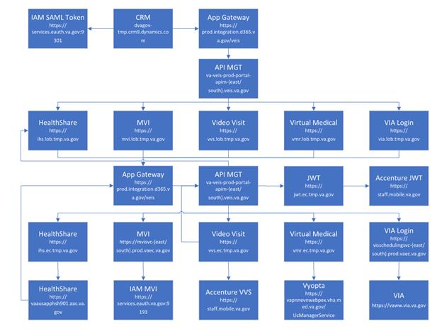

Figure 1: TMP/VEIS (LOB & EC) Environment Mapping

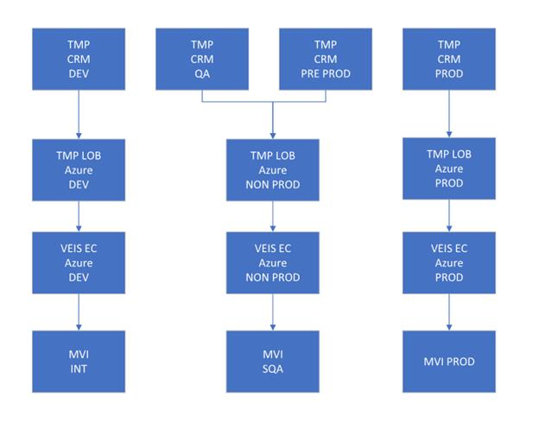

Figure 2: TMP/VEIS/MVI Environment Mapping

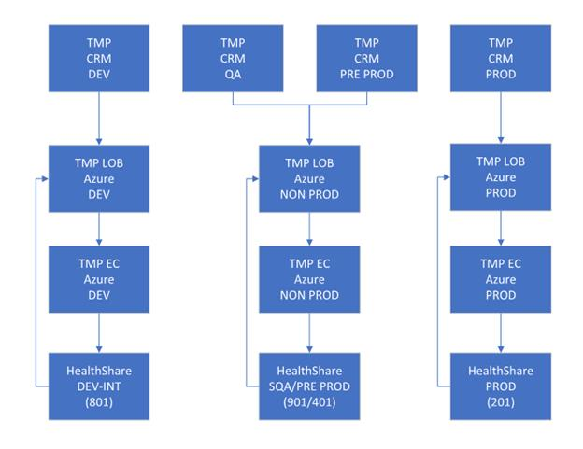

Figure 3: TMP/VEIS/ HealthShare Environment Mapping

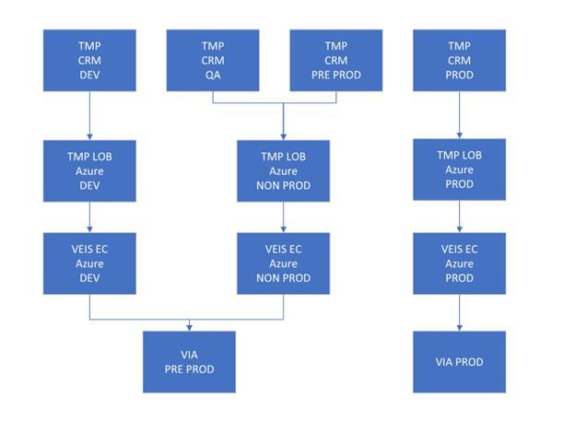Figure 4: TMP/VEIS/VVS Environment Mapping

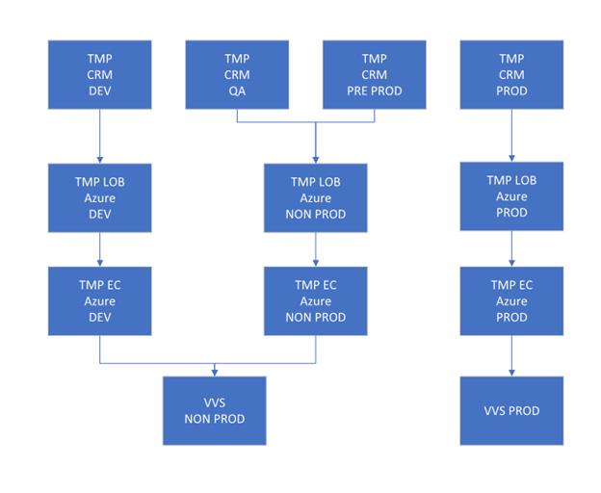Figure 5: TMP/VEIS/VVS Environment Mapping

## 1.3 Constraints

There are no additional constraints to this project.

# Roles and Responsibilities

Table 1: Deployment, Installation, Back-out, and Rollback Roles and Responsibilities

| **ID** | **Team** | **Phase / Role** | **Tasks** | **Project Phase (See Schedule)** |
| --- | --- | --- | --- | --- |
|  | O&M Team, Project Team and Development Team | Deployment | Plan and schedule deployment (including orchestration with vendors) | TMP Release |
|  | O&M Team and Development Team | Deployment | Determine and document the roles and responsibilities of those involved in the deployment. | TMP Release |
|  | Enterprise Operations (EO) | Deployment | Test for operational readiness | TMP Release |
|  | O&M Team | Deployment | Execute deployment | TMP Release |
|  | O&M Team and Development Team | Installation | Plan and schedule installation | TMP Release |
|  | O&M Team/Hosting Team | Installation | Ensure authority to operate and that certificate authority security documentation is in place | TMP Release |
|  | O&M Team/Hosting Team | Installation | Validate through facility POC to ensure that IT equipment has been accepted using asset inventory processes | TMP Release |
|  | Training | Installations | Coordinate training | TMP Release |
|  | O&M Team and Development Team | Back-out | Confirm availability of back-out instructions and back-out strategy (what are the criteria that trigger a back-out) | TMP Release |

This section describes the teams who perform the steps described in this Plan. Representatives from the teams listed in the following table perform deployment and installation activities. This phase begins after the solution design (including deployment topology) is complete. Design activities are not included in this phase.

Table 2: General Roles and Responsibilities

|  |  |
| --- | --- |
| Team | Tasks / Responsibilities |
| **D365 Product Team** | * Deploy code during migrations from lower environments into pre-prod and prod * Coordinate with VA Project Team members, VA NSOC, and Microsoft Support team * Receive and process incoming incidents via Cloud Ticket Determine incident types and capture all relevant incident data Create developer user accounts * Diagnose infrastructure issues * Troubleshoot basic and complex issues Resolve issues |
| **VA Project Team** | * Liaison between the project teams and team members to capture incidents * Submit incident requests using the Cloud Ticket tool |
| **Microsoft Development Team** | * Communicate with CRM Cloud Solution team to provide additional information, if necessary * Identify and submits issues to the VA project POC |
| **Microsoft Development Team** | * Deploy solutions provided by Microsoft Development Team from lower environments into pre-prod and prod * Coordinate with VA Project Team members, VA NSOC, and Microsoft Support team * Receive and process incoming incidents * Determine incident types and capture all relevant incident data * Diagnose incident issues Troubleshoot basic and complex issues Resolve issues |

Table 3: Code Deployment Responsibilities

| Team | Phase | Role |
| --- | --- | --- |
| **Microsoft Development Team** | Planning | * Finalize Development Build and Code Compilation Instructions * Provide listing of developer accounts * Schedule deployment with the CRM Cloud Hosting team via Cloud Ticket |
| **TMP Project Team** | Planning | * Schedule UAT testers and support |
| **Microsoft Development Team** | Prepare for Deployment | * Provide O&M Team with all relevant data/code including: solution extract for CRM, Compiled Code, and ISV Folder, utilizing a method approved by the Project Team (e.g. FTP, Secure Server, or other) * Freeze all development activities |
| **Microsoft Development Team** | Prepare for Deployment | * Review Code Compilation instructions for completion * Work with project teams if compilation instructions are unclear or incomplete * Replicate the existing environment configuration and code * Perform database back-ups |
| **TMP Project Team** | Execute Deployment | * Coordinate deployment support by maintaining the bridge and managing all involved stakeholders * Conduct UAT testing activities |
| **Microsoft Development Team** | Execute Deployment | Work with O&M team to resolve issues, if necessary |
| **O&M Team** | Execute Deployment | Deploy the code into Pre-Prod and Prod |
| **TMP Project Team** | Validation & Go- Live | Validate that the new environment functions as expected |
| **O&M Team** | Validation & Go- Live | Execute roll-back, if necessary |

The following table describes the planned deployment environments.

Table 4: Deployment Environments

|  |  |  |
| --- | --- | --- |
| Environment | Use | Involved Parties |
| Developer Workstations | Development, Unit Testing | Microsoft |
| VA Hosted (NWA) Dev | Development, Unit Testing | Microsoft |
| VA Hosted (NWA) INT | Unit Testing, Integration Testing | Microsoft, VA (Integration) |
| VA Hosted (NWA) QA | User Acceptance Testing | Microsoft, VA |
| VA Hosted (NWA) Pre- Prod | Fallback for Production | Microsoft, VA |
| VA Hosted (NWA) Prod | Production | Microsoft, VA |

# Deployment

The deployment is planned as a single rollout.

This section provides the schedule and milestones for the deployment.

This Release and Installation Guide identifies processes and procedures to promote the Telehealth Management Platform (TMP) Dynamics Customer Relationship Management (CRM) system into the Production Environment. The CRM system is web-based and is deployed using files containing configuration information rather than directly from one environment to another.

* MSTFCERNER [Dev](https://dvagov-mstfcerner-dev.crm9.dynamics.com/)
* MSTFCERNER [QA](https://dvagov-mstfcerner-qa.crm9.dynamics.com/)
* TMP [Pre-Prod](https://dvagov-tmp-preprod.crm9.dynamics.com/)
* TMP [Prod](https://dvagov-tmp.crm9.dynamics.com/main.aspx?appid=ba10663d-e71c-44b6-a23f-bbfbbe61beaf&forceUCI=1&pagetype=entitylist&etn=serviceappointment&viewid=67be10ba-1dd4-40f8-b940-e9e01ef00534&viewType=1039)
* Git Hub <https://github.com/department-of-veterans-affairs/crm-tmp-product>

## 3.1 Timeline

The deployment and installation will run for approximately 1 day*,* as depicted in the master deployment schedule TMP.

In most Deployment Plans, Enterprise Operations (EO) maintains the master schedule in MS Project Server, Field Operations and Development (FOD) maintains its schedule in Clarity, and FOD provides site scheduling to meet parameters and milestones enumerated above. Given the agile methodology used to develop and deploy TMP, along with the limited scope of this software-only deployment/installation, there is no need for a Master Deployment Schedule. The high-level schedule included below will suffice.

Table 5: High Level Milestones

| Milestones | Target Date |
| --- | --- |
| Unit Testing Completed | 12/23/2022 |
| Software Quality Assurance Testing Completed | 1/13/2023 |
| Pre-Production Testing Completed | 2/10/2023 |

## 3.2 Site Readiness Assessment

This section discusses the locations that will receive the TMP deployment. Topology determinations are made by ESE and vetted with PD, FO, NDCP, and the PMO during the design phase as appropriate. Field site coordination will be completed FO unless otherwise stipulated by FO. The Microsoft team provides input and support to all ESE, PD, FO, NDCP, and the PMO team during the site readiness assessment. TMP is a minor application covered under CRM/UD. Site readiness will be assessed in the hosting environment.

This section discusses the locations that will receive the TMP deployment.

### 3.21 Deployment Topology (Targeted Architecture)

Deployment will be conducted through web client in a QA, Pre-Prod, and Production environment administered by O&M, managed by Microsoft.

The CRM system is web-based and is deployed using files containing configuration information rather than directly from one environment to another.

### 3.22 Site Information (Locations, Deployment Recipients)

The CRM system is web-based and is deployed using files containing configuration information rather than directly from one environment to another.

### 3.23 Site Preparation

TMP will be accessed using the browser.

Table 6: Site Preparation

|  |  |  |  |  |
| --- | --- | --- | --- | --- |
| Site/Other | Problem/Change Needed | Features to Adapt/Modify to New Product | Actions/Steps | Owner |
| All Sites | Familiarization with application | N/A | Attend training sessions | Office of Connected Care-Telehealth Training Team |
| All Sites | Data Migration | N/A | Metadata Import into Production | Liberty Development team |
| All Sites | Establish access to TMP URL | N/A | Grant access to application users of TMP | Will be handled by the appropriate region/site |

## 3.3 Resources

This section describes hardware, software, and facilities required for the TMP deployment and installation.

### 3.31 Facility Specifics

Current TMP release will deploy on CRM cloud hosted environment. There are no facility-specific features required for deployment.

Table 7: Facility-Specific Features

| Site | Space/Room | Features Needed | Other |
| --- | --- | --- | --- |
| None |  |  |  |

### 3.32 Hardware

Current TMP release will be supported by the existing cloud hosted environment. No hardware specifications exist.

Table 8: Hardware Specifications

| Required Hardware | Model | Version | Configuration | Manufacturer | Other |
| --- | --- | --- | --- | --- | --- |
| None |  |  |  |  |  |

Please see the Roles and Responsibilities table in Section 2 for details about who is responsible for preparing the site to meet these hardware specifications.

### 3.33 Software

Current TMP release will be utilizing approved existing software on TRM tools list. No software specifications exist.

Table 9: Software Specifications

| Required Software | Make | Version | Configuration | Manufacturer | Other |
| --- | --- | --- | --- | --- | --- |
| None |  |  |  |  |  |

Please see the Roles and Responsibilities table in Section 2 above for details about who is responsible for preparing the site to meet these software specifications.

### 3.34 Communications

A VA Teams meeting will occur for all members involved and/or invested in TMP deployment. All members involved and/or invested in TMP Deployment will receive status emails throughout the deployment activities.

Table 10: Team Support Information/Role

| Team Support Information | Role | POC |
| --- | --- | --- |
| Communication Lead  *Scheduled* | Serves as the main communication and coordination POC on behalf of the application to provide regular status updates and issue escalation. | Mentor Cavazos  [mentor.cavazos@va.gov](mailto:mentor.cavazos@va.gov) |
| Functional Tester(s)  *Scheduled* | Performs testing to verify that application is functioning as expected. | John Smith  [john.smith4@va.gov](mailto:john.smith4@va.gov)  Mario Nunez  [mario.nunez@va.gov](mailto:mario.nunez@va.gov) |
| Development  *On Call* | Development resources are typically on-call for production deployments unless they are required to serve as advisory resources during the release activities. | Rich Carr [richard.carr2@va.gov](mailto:richard.carr2@va.gov)  Peter Cisewski  [peter.cisewski@va.gov](mailto:peter.cisewski@va.gov) |
| VA OIT  *On Call* | Engage OIT contacts if decisions need to be made on behalf of the application and as voting members on the Go/No Go calls. |  |
| VA Business / TDD  *On Call* | Engage Business Contacts if decisions need to be made on behalf of the application and as voting members on the Go/No Go calls. |  |
| Application Support  *Scheduled* | Application Support contacts are scheduled to perform Production code releases and infrastructure changes. |  |
| Hosting Support  *On Call* | Hosting Support contacts are scheduled to perform infrastructure changes or otherwise scheduled to be on call. |  |
| Integration Partners  *Scheduled* | Typically, on-call support for the implementation or update of web service partner connections. |  |

#### 3.3.4.1 Deployment/Installation/Back-Out Checklist

This section will be completed once each task is complete.

Table 11: Deployment/Installation/Back-Out Checklist

|  |  |  |  |
| --- | --- | --- | --- |
| Activity | Day | Time | Individual who completed task |
| Deploy | TBD | TBD | All Nationwide VistA Production Sites Patch Installers |
| Install | TBD | TBD | All Nationwide VistA Production Sites Patch Installers |
| Back-Out | TBD | TBD | All Nationwide VistA Production Sites Patch Installers |

# Installation

## 4.1 Pre-installation and System Requirements

Customer-approved user stories and defects will be stored on the TMP Azure DevOps:

## 4.2 Platform Installation and Preparation

TMP ORG is backed up by a member of the team the night of deployment.

Deployment occurs during off hours.

Software installs within 60-120 minutes.

## 4.3 Download and Extract Files

The CRM system is web-based and is deployed using files containing configuration information rather than directly from one environment to another.

**Table 12: File Inventory List**

| Filename |
| --- |
| https://github.com/department-of-veterans-affairs/crm-tmp-code/blob/cernerdevelopment/Solutions/CernerRelease/TMPRelease5000_5_0_0_0.zip |

## 4.4 Access Requirements and Skills Needed for the Installation

Microsoft Dynamics CRM Security Role – System Administrator

## 4.5 Installation Procedure

Refer to the *TMP* *5.0.0.0 Deployment Instructions* (Appendix A).

## 4.6 Installation Verification Procedure

Refer to the *TMP Releases Deployment Instructions* (Appendix A). Verification/Testing Steps begin on page 1 of Appendix A.

For detailed testing, please also refer to the *TMP Releases Verification Testing Instructions* (Appendix A).

Notification sent to the field via email from Office of Connected Care Help Desk (OCCHD) .

Users were informed of upcoming changes on a weekly call.

## 4.7 System Configuration

Refer to the *TMP Combined Releases TMP 5.0.0.0 Deployment-Verification Testing Instructions* (Appendix A).

# Back-Out Procedure

Refer to the *O&M Backout and Rollback Plan* (Appendix B).

# Rollback Procedure

TMP ORG is backed up the night of deployment.

## 6.1 Rollback Considerations

Go/No-Go meeting will enable a decision to provide viability to proceed.

## 6.2 Rollback Criteria

Restore backup of Production environment taken prior to deployment.

## 6.3 Rollback Risks

No risks exist.

## 6.4 Authority for Rollback

Refer to the *O&M Backout and Rollback Plan* (Appendix B).

## 6.5 Rollback Procedure

* A member of the Development Team will be assigned to this deployment.
* Evening prior to deployment – Approximately 10 pm a backup of TMP Production Environment
* Deployment Date– Upon completion of deployment activities (Installation, Verification, Testing), Go/No Go meeting will take place involving Stakeholders listed in 6.4. If decision of No Go is made, Rollback procedure will commence.
* Deployment Date – 02/17/2023

## Rollback Verification Procedure

| Folder | Filename |
| --- | --- |
| See Section 4.6 | See Section 4.3 |

# Appendix A – TMP Release Deployment Instructions

This section provides steps to deploy the TMP related changes in the Production environment:

https://github.com/department-of-veterans-affairs/crm-tmp-code/tree/Release/Solutions/Release/TMPRelease5000

# Appendix B – TMP ReleaseBackout and Rollback Plan

### **Deployment, Installation, Backup, Restore Instructions for TMP Release 5.0.0.0 2/17/2023**

# Backup:

1. Navigate to the <https://gcc.adminb.powerplatform.microsoft.us/environments>
2. Select the production environment “VA TMP Prod”.
3. Create a manual backup as shown below: 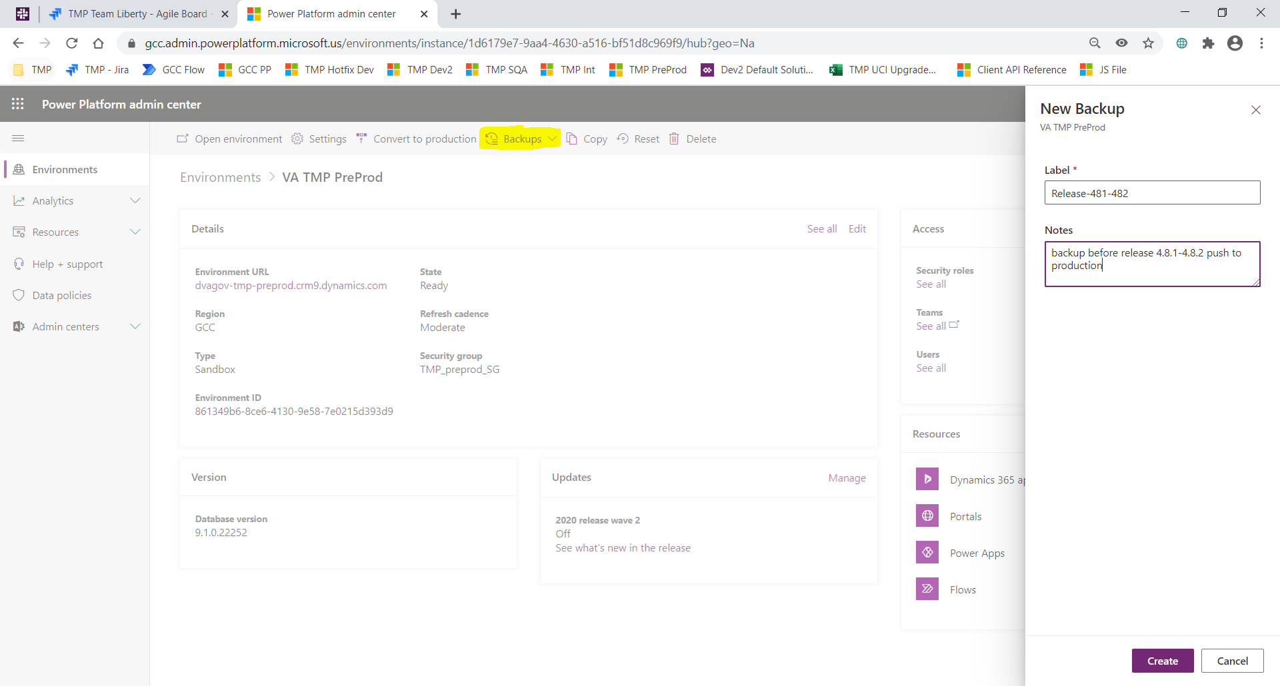
4. Please wait till you see a message similar to below:

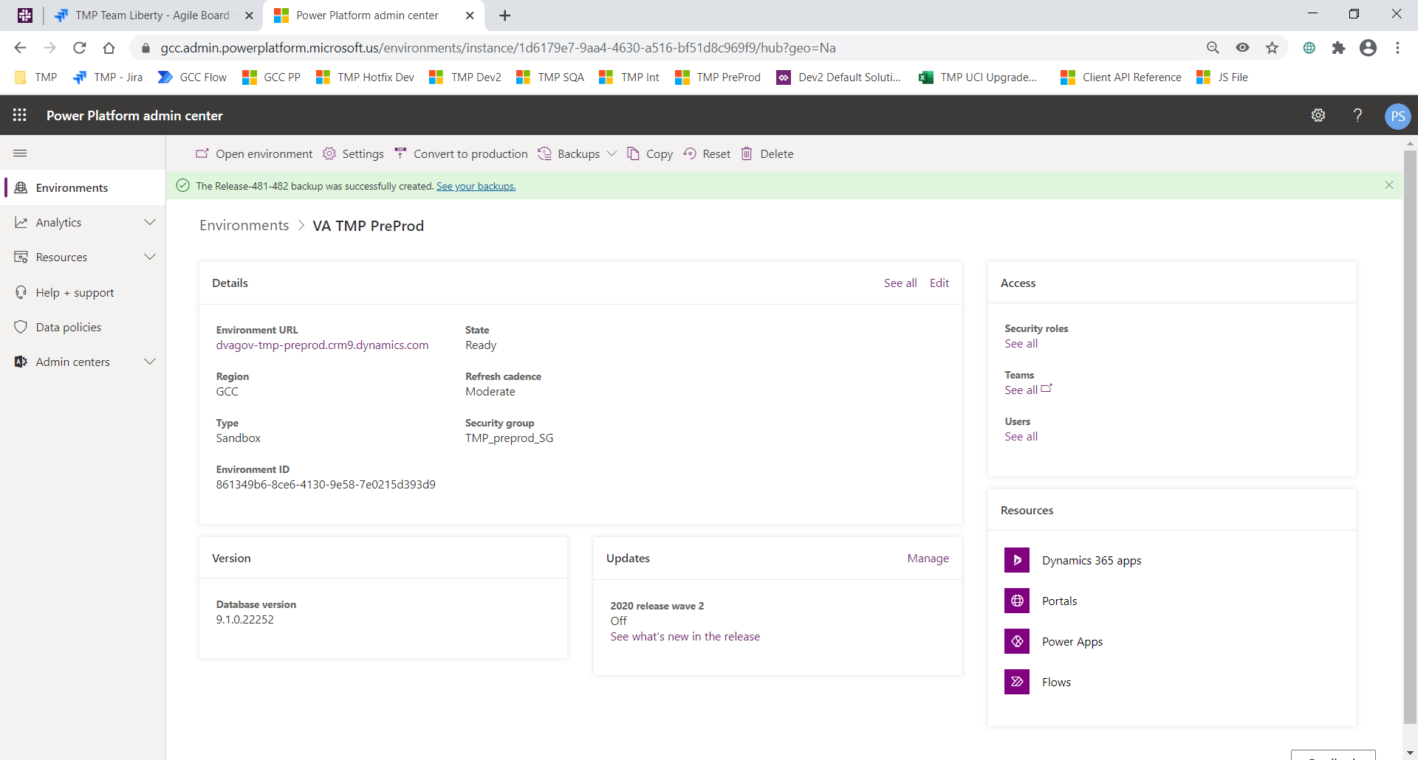

# Deployment Instructions:

This section provides steps to deploy the TMP related changes in the Production environment:

**Solution Deployment:**

Solution TMP-5.1.1 needs to be imported/deployed. You can get the solution here: [crm-tmp-code/Solutions/Release 5.1.1 at Development · department-of-veterans-affairs/crm-tmp-code (github.com)](https://github.com/department-of-veterans-affairs/crm-tmp-code/tree/Development/Solutions/Release%205.1.1)

**Integrations Deployment (Kudu)**

1. Backup the website. Log into Kudu for either the Prod East or Prod South regions for the HealthShare LOB App Service. If you don't have the Publish Profile(s) for them you'll need to log into Azure and download them, first. Use the publishUrl, userName and UserPwd values from the Publish Profile to log into Kudu.
2. Select the CMD option from the Debug console menu.  
   Graphical user interface, application

   Description automatically generated
3. Then click on site link.
4. Click on the download icon for the wwwroot folder and save it off to your GFE.  
   Graphical user interface, text, application

   Description automatically generated
5. Open Integration Solutions Project in Visual Studio
6. Locate the Healthshare API Project in the LOB Api Folder (VA.TMP.Integration.Api.Healthshare)
7. Either Right click on the Project and select the Publish option, or select the Publish option from the Build Menu.
8. Select either the Prod East or Prod South Publish Profile from the menu. If you do not currently have those Profiles as seen here you'll need to download them from Azure and Import them into Visual Studio, first.  
   Graphical user interface, text

   Description automatically generated
9. Click Publish.
10. Repeat Steps 4 and 5 for the other remaining Region (i.e. East or South).

**Manual Configuration:**

1. TMP-2480:
   1. Follow steps outlined in this knowledge base article from Microsoft for enabling the Async OnSave feature to fix this issue: <https://learn.microsoft.com/en-us/power-apps/developer/model-driven-apps/clientapi/reference/events/form-onsave#enable-async-onsave-using-app-setting>
2. TMP-2349:
   1. Update the VA.TMP.Integration.Plugins assembly using Plugin Registration Tool.
   2. Import Solution containing WebResource.

# Restore

1. Navigate to the <https://gcc.admin.powerplatform.microsoft.us/environments>
2. Select the production environment “VA TMP Prod”.
3. Select Restore or manage under “Backups” link:

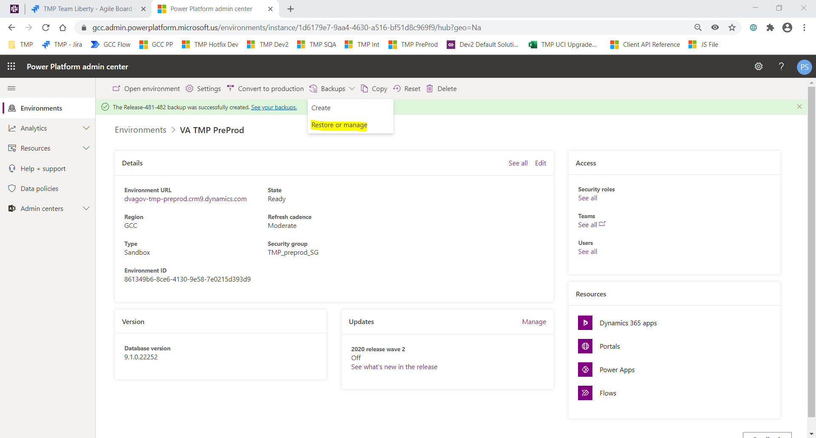

1. Select the backup created in Backup step #1 -> Click Restore

